Donate Your Kit
Sports Participation Programme
Sponsored by Cadbury
GRANT GUIDELINES
The purpose:
1 in 8 Kiwi kids feel excluded from sport because of their family’s circumstances. We have partnered with Cadbury and ‘Donate Your Kit’ to set up grants to assist sports participation so that children do not have to miss out. The aim of the programme is to encourage, and to recognize the pursuit of children’s wellbeing through sporting participation in their communities.

In New Zealand, and especially in our smaller communities, schools are often the heart of the community. Therefore, the programme has targeted schools as the ‘hub’ for their communities.

We understand the opportunity to attend one-off events such as sports trips or tournaments can be difficult for many due to financial hardship. Experiencing and learning from these events can have a lasting impact on a child, boosting confidence as well as promoting a sense of belonging and pride.

The application:
Applies to initiatives, activities and events promoting sports participation for students within your school, in a community or national forum. The applicant must agree and adhere to the criteria for sponsorship and accept decisions made with no right of appeal.

2020 was the first offering for the Sports Grant. We had many successful applicants for individual, team, and school. For the second year running we will be offering individual and team grants only due to grant availability. We would like to support more individuals and teams to succeed in the upcoming year.
G1 Individual  (local/national/regional sports) | G2 Group/Team
Up to $500 | Up to $3000
Can apply for support for an individual student to:  - Attend a tournament/season  - Join a local sports club  - Cost of transport to an event/tournament  - Contribution towards specialised personal equipment or training items  - etc. | Can apply for a group or students or team to:  - Help cover costs of sports/club fees  - Help cover costs of transport  - etc.

CRITERIA
All KidsCan partner schools are eligible to apply for Sports Grant*

* This does not guarantee that all schools that apply will receive a grant. There is a selection process (detailed in ‘Selection’ box)
CONDITIONS AND GUIDELINES
- Applications MUST be made by the principal of the school on behalf of its school community and with approval from the KidsCan Coordinator.
- Related resources and the application link can be found on the Portal as well as the KidsCan website. Applications must be submitted on the KidsCan website by 20 August 2021.
- Applications must demonstrate the estimated impact of the initiative to student wellbeing.
- Applications will be considered that promote sports participation for students – including:
  - Cost of transport to participate in sports competitions – for an individual or a team.
  - Cost of entry for sports competitions – for an individual or a team.
  - Contribution to sports club fees – for an individual or a team.
- Each school can submit as many individual and team grant applications as required.
- An application must be completed in full and must include a budget for the relevant expenses.
- Applicants can apply for both grants and combine funding proposal for multiple students/teams and initiatives in a single application.
- The maximum amount for each application is $3,000. Depending on the nature of the application KidsCan may choose to partially approve the application (i.e. we may only approve the individual but not the team grants or vice versa.)
- The Sports Participation Grant is NOT able to be used for:
  - Staff salary
  - Team uniform
  - Costs associated with after match functions or social gatherings.
- The school will be responsible for ensuring the funds are directed into appropriate activities as described in its application.
- If the competition, season or initiative does not take place/is cancelled and/or an individual student who has received a grant does not attend, KidsCan must be contacted immediately.
GRANT APPLICATION PREVIEW
Once started, this application cannot be saved. Please note for this application you will need to have the following:
- Verbal approval from the KidsCan coordinator
- Supporting information of the event/activity (e.g.: flyer, brochure, newsletter)
- Detailed budget for your application including quotes, fee requests etc
- An official bank deposit slip with your school's account details
The application can be found on the KidsCan portal under ‘Sports Participation Grants’

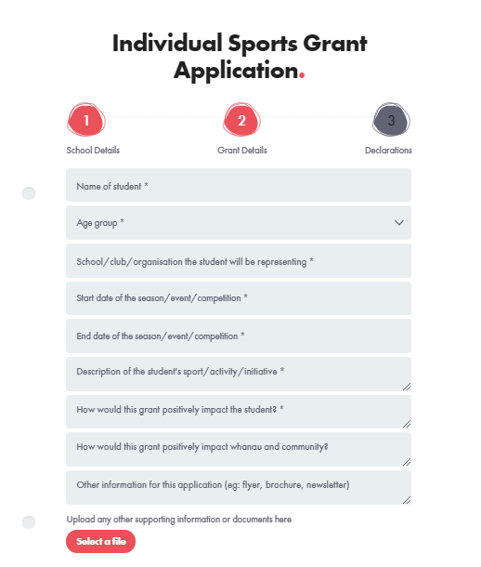
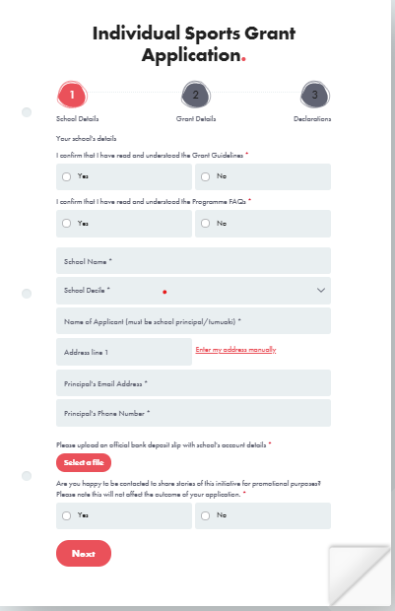

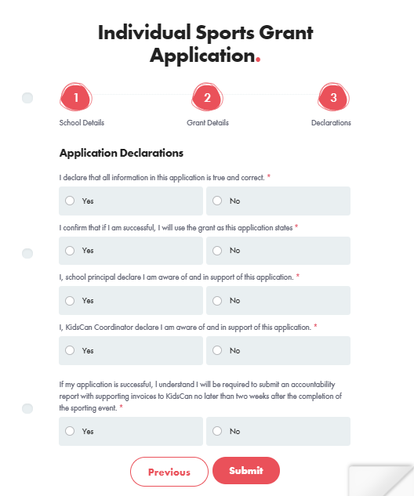
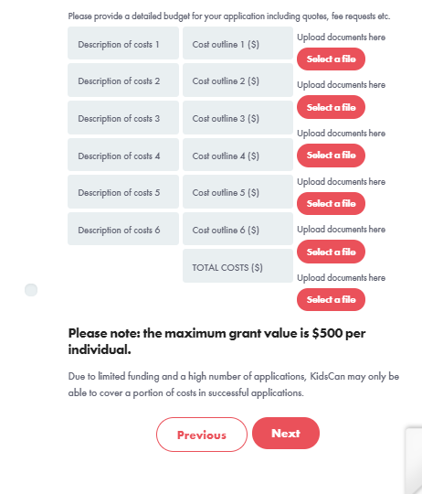

SELECTION
All applications submitted by schools are eligible for the ‘Donate Your Kit Sports Participation Programme’, however priority will be given to applications from the following:
- High deprivation areas, as identified by the New Zealand Deprivation Index 2018 (https://www.ehinz.ac.nz/indicators/population-vulnerability/socioeconomic-deprivation-profile/#references)
- Students aged between 15-18, as identified by the Spotlight on Deprivation (August 2019) as the age group at which participation in sports drops significantly
(https://sportnz.org.nz/assets/Uploads/Active-NZ-Spotlight-on-Deprivation-August-2019.pdf)
- Sports which provide continuity of participation, such as a season with a school or club team as opposed to a one-off event
- Applications which demonstrate the following:
- The level of need of student/school/community
- Outcome they intend to achieve
- What will this mean for their community
- The number of students who will benefit
- Sustainable impact
SPONSORSHIP APPLICATION TIMEFRAME
Applications open 2nd of August 2021.
Applications close the 20th of August 2021.
Schools will be notified if they are successful between August 23rd - September 3rd 2021.
- If successful, the applicant is sent an email containing the conditions of the sponsorship agreement. If the applicant agrees to the conditions, they must reply ASAP by email.
Funds will be distributed by 10th September 2021.
Successful applicants will have until September 2022 to spend the grant money. Impact report MUST be completed and sent through to KidsCan within two weeks after the competition, season or initiative has taken place.

ACCOUNTABILITY / IMPACT REPORT
This needs to be filled out and sent back TWO WEEKS after event/competition/season
Follow up report
e.q. how did the event/competition/season go?

How many children benefitted / were positively impacted by the grant?

